**Name: Michael Hamilton**

**Supervisor: Dr Luis Mejias Alvarez**

**Project Title: Autonomous Helicopter Navigation System – Project Management**

**Year: 2010**

**Volume: 1 of 1**

This project report was submitted as part of the requirements for the award of the

**BACHELOR OF ENGINEERING (Aerospace Avionics)**

in the

SCHOOL OF ENGINEERING SYSTEMS

FACULTY OF BUILT ENVIRONMENT AND ENGINEERING

at the

QUEENSLAND UNIVERSITY OF TECHNOLOGY

BRISBANE, AUSTRALIA

Signature of Candidate

...............................................................

"The great liability of the engineer compared to men of other professions is that his works are out in the open where all can see them. His acts, step by step, are in hard substance. He cannot bury his mistakes in the grave like the doctors. He cannot argue them into thin air or blame the judge like the lawyers. He cannot, like the architects, cover his failures with trees and vines. He cannot, like the politicians, screen his shortcomings by blaming his opponents and hope that the people will forget. The engineer simply cannot deny that he did it. If his works do not work, he is damned."

**Herbert Hoover, 31st President of the United States**

Executive Summary

The 2010 Autonomous Helicopter Navigation System is a Queensland University of Technology 4th year undergraduate Bachelor of Engineering Project. The projects main aim is focused on developing a helicopter system capable of autonomous control, navigation and localisation within a GPS denied environment. The project team are made up of four members, Michael Hamilton, Michael Kincel, Liam O’Sullivan and Tim Molloy. The project was divided up into twenty system requirements, which were used at the end of the project to verify the level of success against in the original aim.

The authors major role in the project was the student manager, which entailed organising the breakdown of the project, the timeline in which objectives had to be completed by, the risk management mitigation steps taken, ensuring the finical budget was not exceeded, and many other system level jobs. The Authors secondary roles were to design and construct the hardware mounting system on the platform, and the testing apparatuses used to lessen the chance of damage/injury during initial testing.

At the conclusion of the project, a traceability matrix was developed to verify the success of the system requirements outlined at the commencement of the project. AHNS 2010 completed 18 out of the 20 system requirements, with one baseline and one derived requirement not passing. The baseline requirement did not pass due to the component no longer being needed in the project, and the derived requirement failed because of safety concerns without necessary equipment.

The main accomplishments of the 2010 AHNS project were the designed and constructed a platform to facilitate flight utilising on board hardware and sensors, implemented State Estimation and PID control to enable autonomous flight, a coded functional ground control station with 2.4 GHz wireless communication to platform, tuned platform gains that achieve stable platform attitude while in flight, and enabled future development on project to achieve position hold.

The 2010 Autonomous Helicopter Navigation System project accomplished most of its system requirements, and produced a platform and software package that will enable future teams to progress to a fully functional indoor autonomous helicopter system

Statement of Authorship

The work contained in this project report has not been previously submitted for a degree or diploma at any other tertiary educational institution. To the best of my knowledge and belief, the project report contains no material previously published or written by another person except where due reference is made.

Signed ……………………..……………………..

Date ……………………..

Acknowledgements

I would first like to thank Luis Mejias for providing the time needed for a project supervisor, the countless advice and giving the members the freedom to make design choices. I hope that the Autonomous Helicopter Navigation System for the years to come get closer to your final goals for the project.

To all the members of AHNS 2010, this project would not have concluded in success without the countless hours spent researching, designing, constructing, coding and testing the quad copter system. It has been a pleasure to work with all of you, and I know the project has given innovative skills and understandings for topics over a broad range of engineering. I hope your futures are just as successful as the outcomes of this project. I would like to thank the ARCAA research facility staff for allowing ongoing testing throughout the semester at their airport hanger.

Finally I would like to thank my family for the constant support in my efforts during my engineering degree, both in the good and the bad.

Table of Contents

Table of Contents v

List of Tables viii

List of Figures ix

Definitions x

1 Autonomous Helicopter Navigation System 11

1.1 Background 11

1.1 Autonomous Helicopter Navigation System 2010 12

1.1.1 Project Members 12

1.1.2 Project 2010 Aim 13

1.1.3 High Level Objectives 13

1.1.3.1 HLO-1 Platform 13

1.1.3.2 HLO-2 Localisation 13

1.1.3.3 HLO-3 State Estimation 14

1.1.3.4 HLO-4 Autonomous Hovering Flight 14

1.1.3.5 HLO-5 Ground Control Station 14

1.1.3.6 HLO-6 Communications 14

1.2 System Requirements 14

1.2.1 Baseline Requirements 14

1.2.2 Derived Requirements 15

1.2.3 Acceptance Tests 17

1.3 Thesis Outline 20

2 Project Management 21

2.1 Systems Engineering Methodology 21

2.2 Management Structure 22

2.3 Documentation Responsibilities 22

2.4 Documentation Standards 23

2.4.1 Document Numbering 24

2.4.2 Project Code and Year 24

2.4.3 Sub-System Codes 24

2.4.4 Document Code and Number 24

2.4.5 Version Control 25

2.5 Resources 25

2.5.1 Financial Resources 25

2.5.2 Services and Facilities 26

2.5.3 Inherited Equipment and Information 27

2.6 Work Breakdown 28

2.6.1 Work Breakdown Structure 28

2.6.2 Project Timeline 29

1.1.1 Work Packages 31

2.7 Risk Management Plan 32

2.7.1 Objective 33

2.7.2 Risk Categories 33

2.7.2.1 Personal Injury 33

2.7.2.2 Property Damage 33

2.7.2.3 Schedule 33

2.7.2.4 Technical 34

2.7.2.5 Budgetary 34

2.7.3 Risk Mitigation 34

2.7.4 Risk Identification Methodology 34

2.7.4.1 Brainstorming and Role Play 34

2.7.4.2 Practical Experience 35

2.7.5 Risk Analysis and Control Plan 35

2.7.5.1 Likelihood 35

2.7.5.2 Consequence 35

2.7.5.3 Risk Rating 36

2.7.5.4 Controls 37

3 Hardware Mounting System Design 38

3.1 High Level Objectives and System Requirements 38

3.2 Design 39

3.2.1 Objectives of Design 39

3.2.2 Payload Information 39

3.3 Design Outline 40

3.3.1 Initial Design 41

3.3.2 Final Design 43

3.4 Implementation 44

3.4.1 Initial Design Implementation 44

3.4.2 Final Design Implementation 45

4 Testing Apparatus Design 47

4.1 Design 47

4.1.1 Objectives of Design 47

4.2 Design Outline 47

4.2.1 Axis Restricted Apparatus 47

4.2.2 Bungee Cord Apparatus 49

4.3 Implementation 49

4.3.1 Axis Restricted Apparatus 49

4.3.2 Bungee Cord Apparatus 50

5 Requirements Traceability and Conformance 51

5.1 Baseline Requirements 51

5.2 Derived Requirements 52

5.3 High Level Objective Conformance 53

5.4 Conformance Diagram 55

6 Conclusions 57

6.1 Lessons Learnt 57

6.1.1 System Level 57

6.1.2 Hardware Mounting System 58

6.1.3 Testing Apparatus 58

Associated Websites 60

List of Appendices 61

List of Tables

Table 1 - Baseline System Requirements 14

Table 2 - Derived System Requirements 16

Table 3 - System Requirements Acceptance Tests 17

Table 4 - Documentation Responsibilities 22

Table 5 - Documentation Standards 23

Table 6 - Sub-System Codes 24

Table 7 - Document Codes 25

Table 8 – AHNS 2010 Finical Budget 26

Table 9 - Services and Facilities 27

Table 10 - Inherited Hardware 27

Table 11: Risk Evaluation Table 36

Table 12: Risk Levels 36

Table 13: Control Measure Risk Reduction 37

Table 14: Control Measure Effectiveness 37

Table 15 – Mounting System Requirements 38

Table 16 - Mounting System Requirement Acceptance Tests 38

Table 17 - Payload Information 40

Table 18 - Traceability Matrix for Baseline Requirements 51

Table 19 - Traceability Matrix for Derived Requirements 52

Table 20 - High Level Objective Conformance Matrix 54

Table 21 - Verification Colour Meaning 55

List of Figures

Figure 1 – AHNS 2009 Platform 11

Figure 2 - Team Members Sub-Systems 12

Figure 3 - Project Stages 21

Figure 4 – Team Management Structure 22

Figure 5 – Work Breakdown Structure 29

Figure 6 – Project Timeline 30

Figure 7 – Illustration of Initial Design (Cinema 4D) 41

Figure 8 – Acrylic Cutter Initial Design in CorelDRAW v14.0 42

Figure 9 – Illustration of Final Design (Cinema 4D) 43

Figure 10 – Acrylic Cutter Final Design in CorelDRAW v14.0 44

Figure 11 – Platform with Initial Electronics Mounting System 45

Figure 12 – Final Design of Mounting System 46

Figure 13 – Battery Mounting for Final Design 46

Figure 14 – Illustration of Axis Restricted Testing Rig (Cinema 4D) 48

Figure 15 – Beam Attaching to Helicopter / Beam Attaching to Frame (Cinema 4D) 48

Figure 16 – Axis Restricted Testing Platform 49

Figure 17 – Bungee Rope Testing Platform 50

Figure 18 – Conformance Diagram 56

Definitions

|  |  |
| --- | --- |
| QUT | Queensland University of Technology |
| AHNS | Autonomous Helicopter Navigation System |
| UAV | Uninhabited Aerial Vehicle |
| HLO | High Level Objective |
| SR | System Requirement |
| AT | Acceptance Test |
| GCS | Ground Control Station |
| CoG | Centre of Gravity |

# Autonomous Helicopter Navigation System

The 2010 Autonomous Helicopter Navigation System is an undergraduate 4th year Bachelor of Engineering Aerospace Avionics project, which mains objective is to provide the students with hands on experiences and systems engineering practices. The project supervisor, Dr. Luis Mejias, outlined the overall goals of the project and was used as a point of contact for concerns with the project.

## Background

Queensland University of Technology has had a successful history of developing uninhabited aerial vehicle for use in civilian airspace at both undergraduate and postgraduate levels for many years. The main purposes for their UAV’s range from search and rescue, surveillance, and data collection. The largest project currently running is Smart Skies, which is progressing to a universal air traffic control measurement to allow unmanned aircraft to safely use the sky while in the presence of other civilian aircraft.

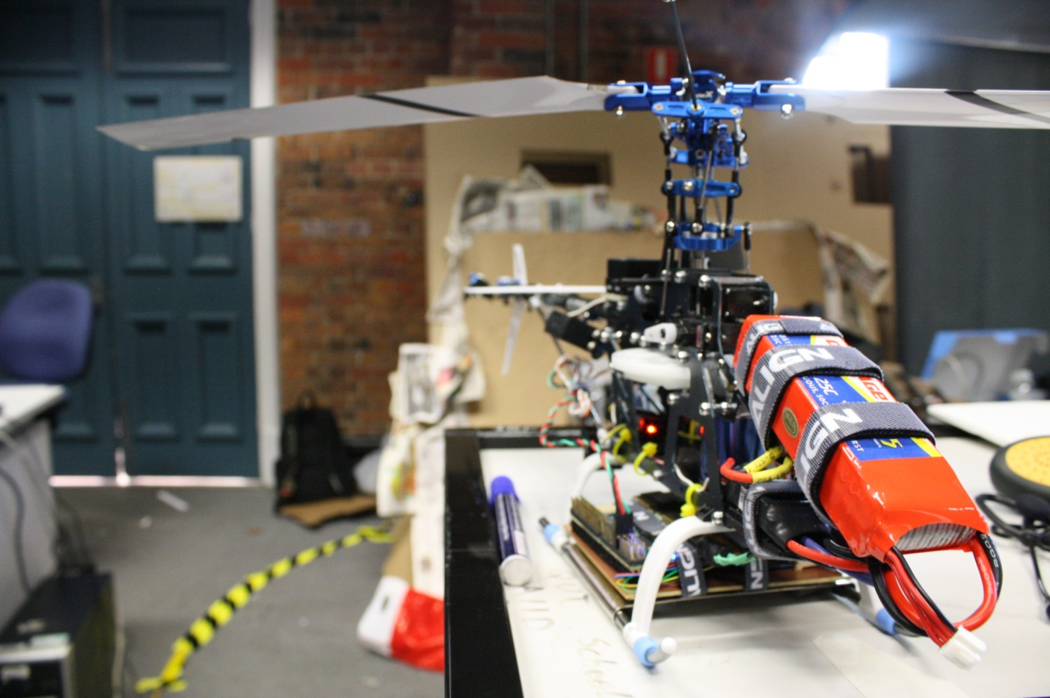The Autonomous Helicopter Navigation System commenced in 2007 under a different title, the Automatic Landing System project. The 2007 projects main objective was to guide a radio controlled helicopter to autonomously land on a platform. The following year the project was renamed AHNS, which the new purpose to design and construct a complete autonomous indoor helicopter system. Each group of students from that point has made progress to the ultimate goal, each using similar approach, which has lead to successful steps forward in development.

Figure 1 – AHNS 2009 Platform

The AHNS 2010 project aims was to further development the platform utilising previous years work, and provide a fully autonomous indoor flying helicopter system.

## Autonomous Helicopter Navigation System 2010

### Project Members

For any project’s success, the duties and roles it in tales must be divided among the team members that are the most suited person for the responsibility, based on their backgrounds and knowledge. The four members for AHNS were split into several sub-systems within the major project. Each student was responsible for their assigned sub-system, but all students contributed to the completion of the tasks. Figure 2 outlines the team member’s assigned sub-systems.



Figure 2 - Team Members Sub-Systems

Michael Hamilton’s major role was the project manager, whose responsibility was to ensure that the high level objectives and system requirements are all met, and that the project is completed within the time schedule. He was also responsible for the hardware mounting sub-system, which entails the design, construction and implementation of the enclosure that supports all hardware mounted in the airframe. He was also responsible for the testing procedures and platforms used throughout all testing of the hardware.

All airframe construction, maintenance and hardware integration tasks was organised by Michael Kincel. This included incorporating all physical sub-systems on the platform to enable autonomous flight. Michael’s secondary role was the pilot for the platform for takeoff, landing and emergency manoeuvres while in autonomous testing.

Liam O’Sullivan’s major role was to ensure that the platform is localised under a known co-ordinate system using an array of sensors. Liam was also responsible for determining the state estimation for the platform to determine the underlying behaviour of the system at any point in time with the use of the IMU and other sensor data.

To ensure that the platform can remain stabilised without the aid of the pilot, a control system was be developed and refined. Tim Molloy’s major responsibility was to determine the control theory for the chosen platform and assign appropriate gains. His secondary role was to develop the GCS from AHNS 2009 to operate with the new platform design.

All members of the 2010 AHNS were responsible for communication between group members, maintenance of equipment and ensuring safety procedures are adhered to for their respective subsystems.

### Project 2010 Aim

The Autonomous Helicopter Navigation System 2010 is focused on developing a helicopter system capable of autonomous control, navigation and localisation within a GPS denied environment. This aim includes the development of all hardware/software utilising off the shelf sensors and computer-on-module devices.

The helicopter will have three switchable modes in which it can operate, manual RC flight, augmented flight, and station keeping. Standard radio controlled flight will be used to maneuver the helicopter while not under the control of the on-board flight computer. Augmented flight mode incorporates velocity vectors being sent to the flight computer, which then moves the helicopter while keeping the attitude stable. Finally station-keeping mode allows the helicopter to remain in a specified co-ordinate while keeping stable.

### High Level Objectives

The High Level Objectives were formulated through discussions between the project customer, the project manager and team members. The 2010 AHNS project has been divided into is high level objectifies that must be completed to achieve the overall project objectives. The HLO’s encompass the platform, localisation, state estimation, autonomous hovering flight, ground control station and communications of the project.

#### HLO-1 Platform

A platform should be developed and maintained to facilitate flight and on board hardware integration.

#### HLO-2 Localisation

The system should be capable of determining its position with the aid of image processing within an indoor environment to an appropriate time resolution.

#### HLO-3 State Estimation

A method of estimating the states of the helicopter system should be designed and implemented. The resolution of the estimations should facilitate their employment in the control system design.

#### HLO-4 Autonomous Hovering Flight

An autopilot system should be developed to enable sustained indoor autonomous hovering flight. The control system should be designed to enable future ingress and egress manoeuvre to longitudinal and hovering flight.

#### HLO-5 Ground Control Station

A ground control station that supports appropriate command and system setting inputs and data display and logging should be developed. The design should be derived from previous AHNS developments and enable future ground station developments.

#### HLO-6 Communications

The communications system should enable transfer of control, state and localisation data to the ground control station. It should provide with a flexible wireless data link available on consumer-electronic devices.

## System Requirements

In order to provide a greater resolution for project requirements, the HLOs described above were derived into baseline and derived system requirements. Baseline requirements are used to describe the objectives that must be met to achieve the HLO’s and are given directly from the customer. Derived requirements are objectives that the project members must also be complete to achieve the HLO’s, but were not stipulated by the customer.

### Baseline Requirements

Baseline requirements are customer defined constraints on the project that are to be met. Ten baseline requirements were identified, denoted as SR-B-01 to SR-B-10.

Table 1 - Baseline System Requirements

|  |  |  |
| --- | --- | --- |
| **Requirement** | **Definition** | **Test Report** |
| SR-B-01 | The platform shall have the ability to be manually manoeuvred with a radio controller. | AT-01 |
| SR-B-02 | The GCS shall enable autopilot flight mode switching between manual, stability augmented flight, and autonomous station keeping. | AT-02 |
| SR-B-03 | The airborne system shall provide control updates at an average rate of 50Hz. | AT-03 |
| SR-B-04 | The estimator shall provide Euler angle and rate estimation for the system an average rate of 50 Hz. | AT-04 |
| SR-B-05 | The estimator shall provide altitude estimation for the system an average rate of 50 Hz. | AT-05 |
| SR-B-06 | The estimator shall provide x and y estimation in an Earth fixed co-ordinate system an average rate of 50 Hz. | AT-06 |
| SR-B-07 | The system shall use image processing to aid in state estimation of x and y in an Earth fixed co-ordinate system. | AT-07 |
| SR-B-08 | The autopilot system gain and reference parameters shall be updatable in flight using an 802.11g WLAN uplink from the GCS. | AT-08 |
| SR-B-09 | The airborne system shall transmit telemetry data including state data to the GCS using 802.11g WLAN. | AT-09 |
| SR-B-10 | The autopilot control methodology shall be based on cascaded PID control loops. | AT-10 |

### Derived Requirements

The derived system requirements were derived through discussions between project group members. Ten derived requirements were developed, denoted as SR-D-01 to SR-D-10.

Table 2 - Derived System Requirements

|  |  |  |
| --- | --- | --- |
| **Requirement** | **Definition** | **Test Report** |
| SR-D-01 | The platform shall be capable of maintaining controlled flight with a total payload of 400 grams. | AT-11 |
| SR-D-02 | A maintenance document shall be used to log airframe flight time, battery cycles and aircraft repairs. | AT-12 |
| SR-D-03 | The autopilot shall provide stability augmented flight. | AT-13 |
| SR-D-04 | The autopilot shall provide autonomous station keeping capability within a 1 meter cubed volume of a desired position. | AT-14 |
| SR-D-05 | The airborne system shall receive and process measurement data from the state estimation and localisation sensors; supporting IMU, Camera, and Ultrasonic sensor. | AT-15 |
| SR-D-06 | The airborne system shall collect avionics system health monitoring information in the form of radio control link status, flight mode status and battery level. | AT-16 |
| SR-D-07 | The airborne system shall transmit all actuator inputs, including radio control inputs, to the GCS. | AT-17 |
| SR-D-08 | The GCS shall log all telemetry and uplink data communications. | AT-18 |
| SR-D-09 | Aircraft state data and control inputs received shall be displayable on the GCS along with appropriate time references. | AT-19 |
| SR-D-10 | The GCS shall provide display of avionics system health monitoring including telemetry, uplink, radio control link and battery level status read-outs. | AT-20 |

### Acceptance Tests

Acceptance testing is used to confirm that a system requirement has been met. Table 3 outlines both the test type and procedure description for each system requirement.

Table 3 - System Requirements Acceptance Tests

|  |  |  |
| --- | --- | --- |
| **Test Report** | **Test Type** | **Testing Procedure** |
| AT-01 | Inspection | The airframe platform will be tested in radio-controlled mode. All basic and advance manoeuvres will be tested to ensure that full control is achieved. |
| AT-02 | Inspection | The GCS will switch between the three modes while the platform in on the ground and while in the air. The operator will ensure that the on-board processor has received the commands and activate the corresponding mode. |
| AT-03 | Testing Log Data | The logged testing data will be analysed to ensure that the processor is outputting control data at an average of fifty times a second. |
| AT-04 | Testing Log Data | Cross-reference the recorded logs to ensure that the Euler angles and rate estimations are correct. |
| AT-05 | Testing Log Data | Cross-reference the recorded logs to ensure that the altitude estimation is correct. |
| AT-06 | Testing Log Data | Cross-reference the recorded logs to ensure that the x and y estimation are correct. |
| AT-07 | Testing Log Data | The camera will be setup up over a pre-measured grid, and comparison between measured position and processor-logged data will be under taken. The same process will be used while the camera is mounted to the platform, to ensure that it operates accurately under flight conditions. |
| AT-08 | Inspection | System gain and reference parameters will be updated from the GCS to the on-board processor. The operator will inspect the platform in-flight to ensure that the uploaded data has been modified. |
| AT-09 | Testing Log Data | Logged telemetry data, including state data, will be inspected to ensure that the on-board processor is sending the correct information, and that is being received by the GCS. |
| AT-10 | Inspection | The control implementation will be reviewed to ensure PID control is implemented and includes saturation, rate limiters, anti-windup considerations as required. |
| AT-11 | Inspection | The platform will have 400 grams of weight attached, while keeping the CoG in the centre of the airframe, and tested to see if it can lift off the ground. All basic and advance manoeuvres will be tested to ensure that full control is achieved. |
| AT-12 | Inspection | The maintenance log will be checked to ensure airframe flight time, battery cycles and aircraft repairs are reported on for the hours of operation associated with 2010 activities. |
| AT-13 | Inspection | The platform will receive movement commands to move in a direction and speed. The platform must move as desired while in stable flight. |
| AT-14 | Testing Log Data | The platform will receive a command to station keep at a fixed co-ordinate for one minute. The telemetry data received at the GCS will be analysed to ensure that it did not move outside a 1 meter cubed volume of the desired position. |
| AT-15 | Testing Log Data | After a flight test while the state estimation and localisation sensors are operating, the on-board computer will be queried to see in the information was received. |
| AT-16 | Testing Log Data | After a flight test while the system health monitoring information are operating, the on-board computer will be queried to see in the information was received. |
| AT-17 | Testing Log Data | After a flight test while the platform is transmitting information to the GCS, the log data will be analysed to ensure that all actuator inputs are received. |
| AT-18 | Testing Log Data | After a flight test while the platform is transmitting information to the GCS, the log data will be analysed to ensure that the telemetry and uplink data communications are received. |
| AT-19 | Inspection | During the flight test, the transmitted aircraft state data and control inputs will be inspected on the GSC for accuracy. |
| AT-20 | Inspection | During the flight test, the transmitted avionics system health monitoring including telemetry, uplink, radio control link and battery level status will be inspected on the GSC for accuracy. |

## Thesis Outline

This thesis outlines the AHNS 2010 projects aims, high level objectives, and system requirements in chapter 1. This information was used to define the direction of the project throughout the year, and was tested against the acceptance testing for verification of success.

Chapter 2 outlines the project management used throughout the year, including the documentation standards, finical budget, work breakdown structure, risk management plan and work packages.

Chapter 3 discusses the design and development of the hardware mounting system for all on-board sensors, computers, batteries and cameras on the platform.

Chapter 4 describes the testing apparatuses developed to mitigate the risks involved in flight testing.

Chapter 5 contains the conformance matrix, which describes which functional requirements have been met, and which have not, as well as referring to the supporting test reports.

Finally, Chapter 6 concludes the thesis with a summary of what was done and recommendations for future progress.

# Project Management

## Systems Engineering Methodology

Large engineering projects can be broken down into five primary stages of development using the NASA systems engineering handbook standard, which are illustrated in Figure 3. This process was followed closely to ensure that the AHNS project had a structured approach in development. Stage one consists of Defining the objectives and system requirements for the project. Initial research was also carried out within each sub-system that can include overview of previous years documents and performing trade studies. Stage two outlines the chosen design that will achieve the HLO’s and SR’s prepared in a preliminary design document. Once the design was finalised, the individual components were acquired and constructed.

Stage three outlines the individual components testing, which ensures that each component achieves its own purpose before integration with the system. Stage four consists of integration of all the individual components into the whole system. The system is then tested to ensure that it achieves the HLO’s and SR’s. Finally stage five involved the delivery of the product to the customer, which in tales demonstration and presentations.



Figure 3 - Project Stages

## Management Structure

The 2010 Autonomous Helicopter Navigation System project team can be divided into three tiers of management structure. Dr Luis Mejias, the project supervisor and client, is at the top tier overlooking the entire project and the group members. On the middle tier is the project manager, Michael Hamilton, whose responsibility in the management structure is to keep the project supervisor informed of the projects progress. Michael Kincel, Liam O’Sullivan and Tim Molloy make up the bottom tier. Their responsibility, along with Michael Hamilton, is to complete the tasks outlined in this document within the given time frame. The figure below outlines the three-tier management structure.



Figure 4 – Team Management Structure

## Documentation Responsibilities

All students in the 2010 AHNS project were required to submit documents which outline steps taken in their respective sub-system. A person other than the author must check each document produced. It is the responsibility of the author of the document to ensure that it is checked by another group member. Both the project manager and supervisor must also approve the document. Table 4 outlines the major documentation and responsible team members for the AHNS project.

Table 4 - Documentation Responsibilities

|  |  |
| --- | --- |
| Team Member | Document Responsibilities |
| Michael Hamilton | High Level Objectives  System Requirements  Project Management Plan  Risk Management  Traceability Matrix  Initial Design Document  Detail Design Document  Test Reports |
| Michael Kincel | Trade Studies  Initial Design Document  Detail Design Document  Test Reports |
| Liam O’Sullivan | Trade Studies  Initial Design Document  Detail Design Document  Test Reports |
| Tim Molloy | Trade Studies  Initial Design Document  Detail Design Document  Test Reports |

## Documentation Standards

To ensure consistency between all documentation AHNS will adopt the QUAV documentation standards. All documentation produced will utilise the corresponding document template or program:

Table 5 - Documentation Standards

|  |  |
| --- | --- |
| Document Type | Template / Program |
| Minutes | MoM.dot |
| Test Reports | Avionics_TR.dot |
| Other Documents | Avionics.dot |
| Project Timeline | Microsoft Project |
| Diagrams | Microsoft Visio |
| Circuit Schematics | CADSoft Eagle |

### Document Numbering

All documentation within the AHNS project must follow strict naming convention to ensure that system identification and traceability can be maintained. The naming convention for all official AHNS documentation is as follows.

*<Project Name>-<Project Year>-<Subsystem Code>-<Document Code>-<Document Number>*

An example for this is the project management plan, under the system level sub-system, AHNS-2010-SY-PM-001

### Project Code and Year

The project code and year for all official documents will be AHNS 2010. This code allows external readers to indentify the project and year of development.

### Sub-System Codes

To differentiate between each sub-system within the AHNS project, a code is assigned to identify the document to belonging to that system. Table 6 outlines the corresponding codes for each sub-system.

Table 6 - Sub-System Codes

|  |  |
| --- | --- |
| Subsystem | Code |
| System Level | SY |
| Platform | PL |
| Autopilot | AP |
| Localisation | LO |
| State Estimation | SE |
| Ground Control Station | GC |
| Communication | CO |

### Document Code and Number

All sub-systems will have many different types of documents associated with them. An additional document code will also be included into the name to aid in categorising the reports. Table 7 outlines the all the codes against the type of document that is within the report. Also attached to each document code is a three digit ascending number, which differentiates between multiple documents of the same document code.

Table 7 - Document Codes

|  |  |
| --- | --- |
| Document | Code |
| High Level Objectives | HL |
| System Requirements | SR |
| Project Management Plan | PM |
| Trade Study | TS |
| Design Document | DD |
| Test Report | TR |
| Detailed Drawing | DR |
| Traceability Matrix | TM |
| Operations Manual | OM |
| Minutes of Meeting | MM |

### Version Control

As mentioned above, Subversion was used as the project’s version control system. Subversion is freely available, easy to use and very effective in maintaining source code. With the project’s source code located online, any team member can access the code anywhere, at any time, and always have the latest version of any shared code. Subversion also has several other advantages, which are described below.

## Resources

The 2010 Autonomous Navigation Helicopter System project had a range of resources at its disposal, including financial resources, QUT services and facilities, inherited past year equipment and knowledge.

### Financial Resources

The financial resources was be used for purchasing equipment that the 2010 AHNS team require to complete the projects objectives. The project manager conducted all purchases once authorisation from the project supervisor had been granted. It is the project manager’s responsibility to monitor the budget as purchases are made.

Every student within the subject is provided $100 Australian dollars to put towards their project, supplied by Built Environment & Engineering Faculty at QUT. Additional funding was also acquired from Boeing Australia, to the sum of $2000 Australian dollar. This adds to $2400 dollars total for the 2010 AHNS project. Table 8 outlines the all purchases made throughout the project, and the amount of money remaining at the conclusion.

Table 8 – AHNS 2010 Finical Budget

|  |  |  |  |  |
| --- | --- | --- | --- | --- |
| Company | Item Description | Credit | Debit | Total |
| QUT | BEE Unit Funds | $400.00 | $0.00 | $400.00 |
| Boeing | Boeing Sponsorship | $2000.00 | $0.00 | $2400.00 |
| HiSystems GmBH | Quad Copter Airframe | $0.00 | $759.86 | $1640.14 |
| Surveyor Corporation | Camera | $0.00 | $248.75 | $1391.39 |
| Gumstix inc | On-board Computer | $0.00 | $395.92 | $995.47 |
| HobbyRama | RC Components | $0.00 | $82.00 | $913.47 |
| Bunnings Warehouse | Glue | $0.00 | $16.03 | $897.44 |
| Eckersly | Wiring Equipment | $0.00 | $29.95 | $867.49 |
| QUT Bookshop | Writing Materials | $0.00 | $5.70 | $861.79 |
| Jaycar Australia | Cable | $0.00 | $10.67 | $851.12 |
| RS Components | Coolum Counter | $0.00 | $37.07 | $814.05 |
| Farnel | Electrical Parts | $0.00 | $138.33 | $675.72 |
| H.E.Supplies | Metal Components | $0.00 | $44.85 | $630.87 |
| New Generation Hobbies | Motors | $0.00 | $221.55 | $409.32 |
| Hobby King | Electronic Speed Controllers | $0.00 | $100.53 | $308.79 |
|  |  |  | **Total Remaining** | **$308.79** |

### 

### Services and Facilities

The 2010 AHNS team had several services and facilities at their disposal, which provided a range of benefits for the project. Table 9 outlines the available services and facilities located in QUT’s garden point campus.

Table 9 - Services and Facilities

|  |  |  |  |
| --- | --- | --- | --- |
| **Location** | **Availability** | **Access** | **Resources** |
| S-Block Level 11 Avionics Lab | 24 hours/day | Avionics students | Tools, Soldering Iron, electronic parts, computers, storage, electronic measuring equipment. |
| S-Block Level 11 Computer Lab | 24 hours/day | Electrical and Avionics Students | Computers. |
| S-Block Level 9 Shop | Business hours (Monday – Friday) | Electrical and Avionics Students | Tools, electronic parts, PCB manufacturing. |
| S-Block Level 9 Lab | Business hours (Monday – Friday) | Electrical and Avionics Students | Soldering Iron, electronic parts, computers, and electronic measuring equipment. |
| J-Block | Business hours (Monday – Friday) | Engineering Students | Laser Cutter. |

### Inherited Equipment and Information

The AHNS 2010 team had inherited several items from previous year’s helicopter projects, including both documentation and hardware. The table below lists the description and quantity of all inherited hardware.

Table 10 - Inherited Hardware

|  |  |
| --- | --- |
| Hardware Description | Quantity |
| TREX450 (Nancy) | 1 |
| Blade400 (Emily) | 1 |
| TREX450s kit box | 1 |
| Tracking antenna PCB | 1 |
| Sensor dynamics IMU (1 working) | 2 |
| XBEE ground station  box | 1 |
| 325mm wood main rotor blade | 4 |
| Metal tail rod | 1 |
| Stereo camera | 1 |
| Spektrum DX6i | 1 |
| Easy radio | 4 |
| Eflite landing gear strut set | 1 |
| Servo extensions (400 mm) | 5 |
| 6v 2000mAH NiMH | 1 |
| 6v Intellect NiMH | 1 |
| Dean connectors | 2 |
| Eflite 7.4V 800mA | 1 |
| 3-cell 12V 2200 mAH LiPO damaged | 1 |
| 3-cell 12V 2200 mAH LiPO | 3 |
| 7.4V 800mA Li | 1 |
| USB-Serial connector | 1 |
| Twister 2 cell LiPO charger | 1 |
| Eflite O ring set | 11 |
| USB -> blackbox -> Stereo jack | 1 |
| BNC to alligator clips | 1 |
| Zippy ties | 10 |
| Swann webcam | 1 |

## Work Breakdown

### Work Breakdown Structure

The work breakdown structure was managed using bottom side up approach, which conforms to NASA’s guidelines for systems engineering. A work breakdown structure was used to organise the individual pieces of work into a logical order to illustrate what order they must be completed. The systems engineering methodology is also outlined in the work breakdown structure.



Figure 5 – Work Breakdown Structure

### Project Timeline

The Gantt chart schedule in Figure 6 illustrates the AHNS timeline for each of the work packages mentioned in the Work Breakdown Structure.

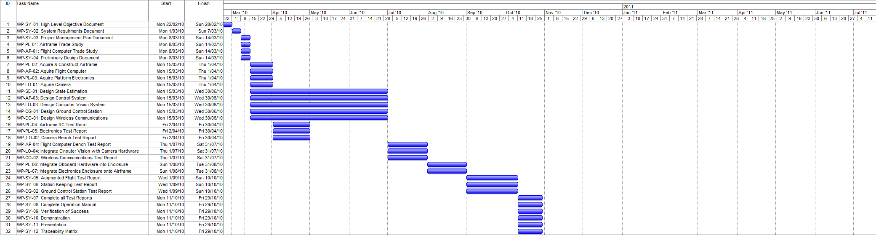

Figure 6 – Project Timeline

### Work Packages

Work Packages outline all the tasks to be completed to achieve the high level objectives and system requirements outlined in chapter 1. The work packages have been produced according to the Work Breakdown Structure in section 2.6.2 and allocated time frames according to the Project Schedule in section 2.6.3. The work packages are categorised using the system engineering methodology stages. Full details of each work package, including description, due dates, and persons responsible are outlined in the appendix A.

|  |  |
| --- | --- |
| **Stage One: Research and Define** | |
| **System Level** | WP-SY-01: High Level Objectives Document  WP-SY-02: System Requirements Document  WP-SY-03: Project Management Document |
| **Platform** | WP-PL-01: Airframe Trade Study |
| **Autopilot** | WP-AP-01: Flight Computer Trade Study |
| **Stage Two: Design and Develop** | |
| **System Level** | WP-SY-04: Preliminary Design Document |
| **Platform** | WP-PL-02: Acquire and Construct Airframe  WP-PL-03: Acquire Platform Electronics |
| **Autopilot** | WP-AP-02: Acquire Flight Computer  WP-AP-03: Design Control System |
| **State Estimation** | WP-SE-01: Design State Estimation |
| **Localisation** | WP-LO-01: Acquire Camera  WP-LO-03: Design Computer Vision System |
| **Ground Control Station** | WP-GC-01: Design Ground Control Station |
| **Communications** | WP-CO-01: Design Wireless Communications |
| **Stage Three: Component Testing** | |
| **Platform** | WP-PL-04: Airframe RC Test Report  WP-PL-05: Electronics Test Report |
| **Autopilot** | WP-AP-04: Flight Computer Bench Test |
| **Localisation** | WP-LO-02: Camera Bench Test |
| **Communications** | WP-CO-02: Wireless Communications Test |
| **Stage Four: Integration and Testing** | |
| **Localisation** | WP-LO-04: Integrate Computer Vision with Camera |
| **Platform** | WP-PL-06: Integrate On-board Hardware into Enclosure  WP-PL-07: Integrate Electronics Enclosure into Airframe |
| **Ground Control Station** | WP-CG-02: Ground Control Station Test Report |
| **System Level** | WP-SY-05: Augmented Flight Test Report  WP-SY-06: Station Keeping Test Report  WP-SY-07: Complete all Test Reports |
| **Stage Five: Deliverables** | |
| **System Level** | WP-SY-08: Complete Operations Manuel  WP-SY-09: Verification of Success  WP-SY-10: Demonstration  WP-SY-11: Presentation  WP-SY-12: Traceability Matrix |

## Risk Management Plan

The following section details the risk management procedure for the 2010 AHNS project. The purpose of the plan is to ensure that any incident with potential to harm a team member or delay in progress of the project can be successfully avoided or appropriately handled by following a detailed mitigation procedure. Risk management is an important consideration for any system engineering process. It is standard to categorise risks into several groups, and the full list of risks can be seen in appendix B.

The risk management process involves:

* Determine responsibilities and context of the project.
* Identify hazards within the project.
* Assess the risks existing in each hazard.
* Determine control measures.
* Implement control measures.
* Review effectiveness of control measures.

This document forms an important part of the communication and consultation process.

### Objective

The objective of the Risk Management Plan is to ensure that QUT and persons associated with the AHNS 2009 project are aware of and understand the risks presented by the development and operation of the project, and that no unnecessary risks are undertaken, which do not have a corresponding opportunity or benefit.

### Risk Categories

The following sections detail the risks involved within five categories for the AHNS projects lifecycle.

#### Personal Injury

This plan manages the risks related to personal injury of team members, visitors and the general public including;

* Health and Safety risks to the extent to which the operations of the project can impact on group members, visitors and the general public.
* The risks associated with the use of construction and development tools and equipment.
* Personal injury associated with attending testing and demonstrations sites external to the university.

#### Property Damage

This plan manages the risks associated with damage to the property of the AHNS group and also any property owned by QUT, such as:

* Damage to or loss of the AHNS Helicopter Platform
* Damage to QUT facilities, or external testing sites.
* Damage to construction or development tools.

#### Schedule

This plan manages the schedule related risks to the AHNS 2010 project including;

* Failure to achieve objectives or system requirements of the project.
* The delivery of purchased parts or equipment.
* Student commitments to other subjects and external activities.

#### Technical

The plan manages the technical risks to the AHNS 2010 project including;

* Damage to/loss of helicopter platform.
* Failure during development or flight testing of subsystems.
* Errors in design/planning.
* Inexperience of team members.

#### Budgetary

This plan manages the financial risks to the AHNS 2010 project including;

* Expenditure due to damaged parts.
* Expenditure due to collateral damage.
* Financial impacts as a result of non-compliance with laws or regulations.

### Risk Mitigation

Once risks for the AHNS project are identified, mitigation procedures must be developed in order to minimise potential hazards. Following this risk mitigation procedure will aid in reducing any potential hazard to the safety of individuals, equipment, and the surrounding environment. The following sections detail potential hazards and their mitigation procedures.

### Risk Identification Methodology

The following spread of strategies is being applied to assist in Risk Identification.

#### Brainstorming and Role Play

Brainstorming and role play is a major source or risk identification. This approach essentially involves round table discussions with the AHNS team members and supervisors in order to run through scenarios. This process results in the identification of many hazards which will occur during the development and operation of the project.

#### Practical Experience

AHNS personnel have some background experience in their respective subsystems. This experience is important in identifying hazards and risks. Cases where there is a lack of expertise among the team members, experts on the particular subject will be actively approached to provide support and insight.

### Risk Analysis and Control Plan

Guidance for risk analysis and control has been sought from a number of sources and a tailored risk analysis methodology is presented here.

#### Likelihood

**Almost Certain:**An event which could be expected to occur multiple times throughout the life of the program.

**Likely:**An event which could be expected to occur a few times throughout the life of the program.

**Moderate:**An event which could be expected to occur once or twice throughout the life of the program.

**Unlikely:**An event which could occur, but is not expected to occur throughout the life of the program.

**Rare**An event which is not expected to occur during the program;

#### Consequence

**Insignificant**No injuries, low financial implications

**Minor**  
Possible injuries requiring no more than first aid treatment, medium financial loss.

**Moderate**Possible injuries would require medical treatment, high financial loss.

**Major**Extensive injuries possible, major financial loss.

**Catastrophic**Death is clearly possible, huge financial implications.

#### Risk Rating

The matrix from Risk Management Code of Practice 2007 Supplement 2 is used to evaluate the Risk Rating based on the likelihood and consequence assessments.

Table 11: Risk Evaluation Table

|  |  |  |  |  |  |
| --- | --- | --- | --- | --- | --- |
| **Likelihood** | **Consequences** | | | | |
| **Insignificant** | **Minor** | **Moderate** | **Major** | **Catastrophic** |
| **Almost Certain** | Moderate | High | Extreme | Extreme | Extreme |
| **Likely** | Moderate | High | High | Extreme | Extreme |
| **Moderate** | Low | Moderate | High | Extreme | Extreme |
| **Unlikely** | Low | Low | Moderate | High | Extreme |
| **Rare** | Low | Low | Moderate | High | High |

The following provides guidance on the required actions based on the risk rating.

Table 12: Risk Levels

|  |  |
| --- | --- |
| **Risk Levels** |  |
| 1. Immediate Action Required. Do not proceed with activity | Extreme |
| 2. Senior management attention required. | High |
| 3. Proceed with caution. | Moderate Risk |
| 4. Manage by routine procedures. | Low Risk |

#### 

#### Controls

Each identified risk should have controls applied to ensure that they do not occur. Risk Management Code of Practice Supplement 3 provide guidance on how to prioritise and assess the effectiveness of the proposed controls, and how they affect the residual risk.

Note that residual risk can also be assessed by re-assessing the likelihood and consequence of the adverse event occurring, given the proposed controls; however this does not always yield a true picture of the residual risk. The tables below provide guidance on the preferred types of controls to use in such situations.

Table 13: Control Measure Risk Reduction

|  |  |  |  |  |  |
| --- | --- | --- | --- | --- | --- |
| **Control Measure Effectiveness** | | |  |  | |
|  | **Extreme** | **High** | **Moderate** | | **Low** |
| **Excellent** | Low | Low | Low | | Low |
| **Good** | Moderate | Low | Low | | Low |
| **Fair** | High | Moderate | Low | | Low |
| **Poor** | Extreme | High | Moderate | | Low |

Table 14: Control Measure Effectiveness

|  |  |
| --- | --- |
| **Control measures** |  |
| 1. Eliminate (Best Solution – Eliminate the Risk) | Excellent |
| 2. Substitute (Replace for a less hazardous outcome) | Excellent |
| 3. Engineer (Re-design or modify to lower risk) | Good |
| 4. Isolate (Remove process or operation to a safer location) | Fair |
| 5. Administrate (Create procedural instructions) | Poor |
| 6. Personal Protective Equipment (Last choice) | Poor |

# Hardware Mounting System Design

## High Level Objectives and System Requirements

[HLO-1] Platform from Chapter 1 established that a platform should be developed and maintained to facilitate flight and on board hardware integration. This high level objective encompasses the design of the electronic mounting system.

The electronics mounting sub-system has two system requirements associated with its design, one baseline and one derived outlined in Table 15. Baseline requirements were specified by the customer and from previous AHNS experience whilst derived requirements were developed after a period of preliminary systems design.

Table 15 – Mounting System Requirements

|  |  |  |
| --- | --- | --- |
| **Requirement** | **Definition** | **Test Report** |
| SR-B-01 | The platform shall have the ability to be manually manoeuvred with a radio controller. | AT-01 |
| SR-D-01 | The platform shall be capable of maintaining controlled flight with a total payload of 400 grams. | AT-11 |

The system requirements outline that the platform must be able to operate in flight conditions with a payload of 400 grams. The acceptance tests are listed in the table of system requirements and described in Chapter 1 and Table 16. This therefore requires the electronics mounting to be rigid to allow sudden attitude and position changes, and strong enough to hold 400 grams of payload equipment.

Table 16 - Mounting System Requirement Acceptance Tests

|  |  |  |
| --- | --- | --- |
| **Test Report** | **Test Type** | **Testing Procedure** |
| AT-01 | Inspection | The airframe platform will be tested in radio controlled mode. All basic and advance manoeuvres will be tested to ensure that full control is achieved. |
| AT-11 | Inspection | The platform will have 400 grams of weight attached, while keeping the CoG in the centre of the airframe, and tested to see if it can lift off the ground. All basic and advance manoeuvres will be tested to ensure that full control is achieved. |

## Design

The electronics mounting system for AHNS 2010 underwent several design changes throughout the year due to many factors, such as different payloads being used, the centre of gravity position changing and improvements to design to prevent damage received from crashes. The following section outlines the design choices throughout the semester, and outlines all designs implemented.

### Objectives of Design

There were several objectives for the design of the mounting system that were not outlined in the system requirements. These requirements were put in place to mitigate schedule and finical risk present after serious crashes in flight-testing. The following list outlines the informal requirements for the electronics mounting system.

* The design will protect the electronic equipment from striking the ground or other parts of the airframe in the event of a crash.
* The frame that supports the equipment will be made of a material that will snap under a large instant force, such as a crash, to prevent this shock damaging the main electronics board or airframe.
* The mounting system will be easy and cheap to manufacture, and within a local area to reduce delivery time.
* Vibration dampening will be applied to all electronics boards to ensure data collected is not corrupted with noise.
* Allow easy access to electronics and line of sight to all LED’s.
* Ensure ventilation for electrical components is available.

These informal requirements will be factored into all design choices of the electronics mounting system.

### Payload Information

The dimensions of each electronic payload device are different, and each will require different mounting positions within the platform. Table 17 outlines the dimensions and comments on each component that requires mounting to the platform.

Table 17 - Payload Information

|  |  |  |
| --- | --- | --- |
| **Payload Item** | **Dimensions (L, W, H) / Weight** | **Comments** |
| Main Board | (103.1, 83.0, 42.0) mm  / 180 grams | The board have varying height, with the highest point at 42 mm. The board must be mounted upright, on vibration dampeners. |
| Battery | (107.5, 35.0, 30.0) mm  / 130 grams | The battery is the heaviest component, with deans and charger cable protruding out one end. |
| Switch | (30.0, 15.0, 60.0) mm  / 20 grams | The switch requires a 12 x 12 mm circle hole for mounting, and a lot of area underneath for hanging cables. |
| Ultrasonic Sensor | (22.9, 22.0, 35.0) mm  / 70 grams | Ultrasonic must be mounted upside down with clear line of sight to ground from platform. A 17.5 x 17.5 mm hole must be cut for sensor to fit through. |
| Camera | (102.5, 53.5, 55.0) mm  / 130 grams | Camera requires 20 x 20 mm hole for the lens to see through, and mounted with vibration dampeners. |
| Antenna 1 | (7.0 x 7.0) mm [hole dimension] | The camera antenna needs to be mounted to the airframe through a slot with locking nut. |
| Antenna 2 | (12.3 x 12.3) mm [hole dimension] | Gumstix Overo antenna needs to be mounted to the airframe through a slot and clip. |

The total weight for all components within the payload, as outlined in Table 17, is approximately 400 grams (no including battery). Therefore the mounting system must be able to support that load under flight conditions.

## Design Outline

To satisfy the design objectives outlined in section 4.1, it was decided to utilise a tier design, which consist of several levels of mounting platforms. This will allow easy access, line of sight to the electrical components, and ventilation to cool heat sinks of the payloads. Metal spacers were used to separate the tiers, which provide a very strong structure to house the payload.

QUT J-Block workshop houses an acrylic plastic sheet-cutting machine, which allows computer-designed drawings to be formed automatically. It was decided that this fulfilled all of the requirements, with the material breaking under a desired load. The cutting facility and materials is free to use, and new plates can be acquired in less than an hour.

Industry vibration dampeners were bought with the airframe, and will be used to reduce noise on the main circuit board and camera model.

### Initial Design

The initial design incorporated all payload items outlined in Table 17, which are positioned on a two tier mounting system between the landing gear of the platform. It was decided that the IMU needed to be located as close to the CoM of the platform, so that the acceleration values were as accurate as possible. Therefore the main electronics board, which houses the IMU, was to be mounted on the top tier just underneath the CoM.

The top tier consisted of the main power switch, main electronics board, and both antennas. The bottom tier housed the camera, battery and ultrasonic switch facing downwards. An initial concept design was developed in a 3D animation program called Cinema 4D, and a render is shown in Figure 7.

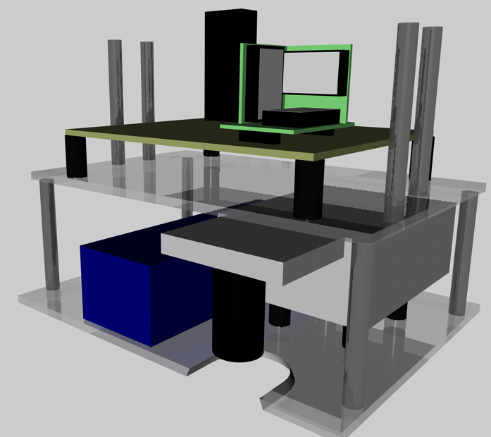

Figure 7 – Illustration of Initial Design (Cinema 4D)

The acrylic cutting machine used Corel Draw version 14.0 files to determine the paths that the cutter used. The program was acquired and the two tier platters were designed to allow mounting locations, payload placing indications and viewing holes. Figure 8 is an illustration taken from the CorelDRAW file, with the first image being the top tier, and the bottom being the lower tier. The program cuts through the plastic on red lines, and engraves blue lines on one side of the acrylic sheet.

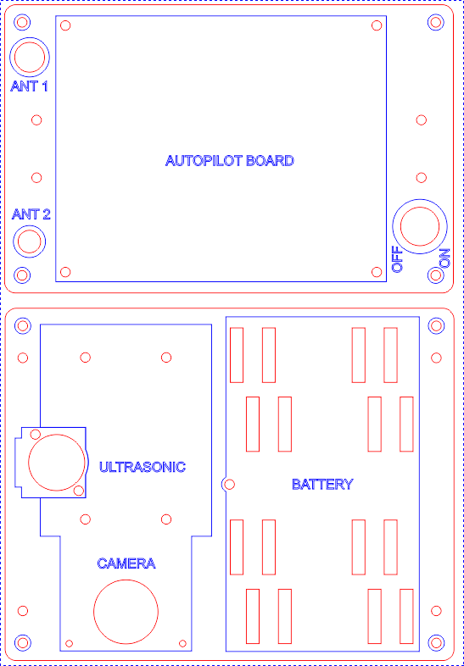

Figure 8 – Acrylic Cutter Initial Design in CorelDRAW v14.0

The top tier is connected to the bottom tier by four 40 mm metal spacers, while the top tier connects to the pre-drilled holes of the lander gear with four 45 mm metal spacers. The battery had several mounting locations to shift the CoM to the desired location.

### Final Design

During the semester the localisation technique for the platform changed, which no longer required the camera to be mounted to the system. This forced changes in the hardware mounting for several reasons. Due to the camera being removed, the CoM could no longer be set to the desired location without adding weights. During initial flight tests it would found with the battery so low, it made the helicopter sluggish to control. Also it was found that in the event of a sudden drop the undercarriage would always hit the ground due to the 2nd tier being to low to the ground. This therefore prompted the bottom tier to be removed with the camera, battery repositioned on top of the platform, and the ultrasonic sensor mounted onto the top tier. An initial concept design was developed in a 3D animation program called Cinema 4D, and a render is shown in Figure 9.

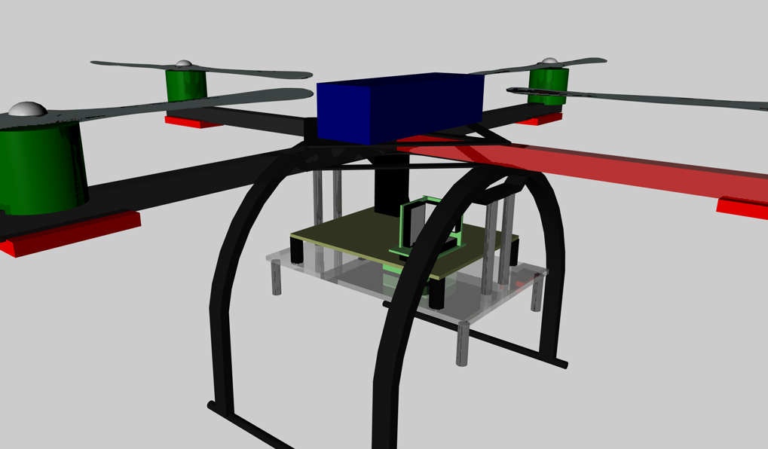

Figure 9 – Illustration of Final Design (Cinema 4D)

The one tier mounting system looks similar to the previous design but the ultrasonic system has been added underneath the autopilot board. Also due to the large length of the cables running under the power switch, it was mounted ninety degrees along the bottom of the tier. The bottom piece of Figure 10 was bent at 90 degrees in the middle and attached to the tier.

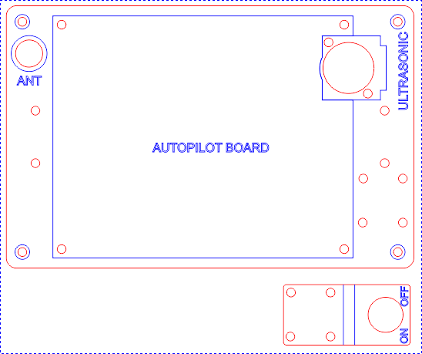

Figure 10 – Acrylic Cutter Final Design in CorelDRAW v14.0

Similar to the initial design, four 45 mm metal spacers were used to attach the tier to the airframe landing gear, and Velcro straps were used to attach the battery.

## Implementation

### Initial Design Implementation

The design mentioned in section 4.3.1 was created at the acrylic plastic sheet-cutting machine, and attached to the airframe with 40 and 45 mm M3 spacers outlined in RD/3. Figure 11 shows the initial design for the mounting system attached. Underneath the bottom platter soft shock absorbers where placed to reduced damage if the platter hit the ground.

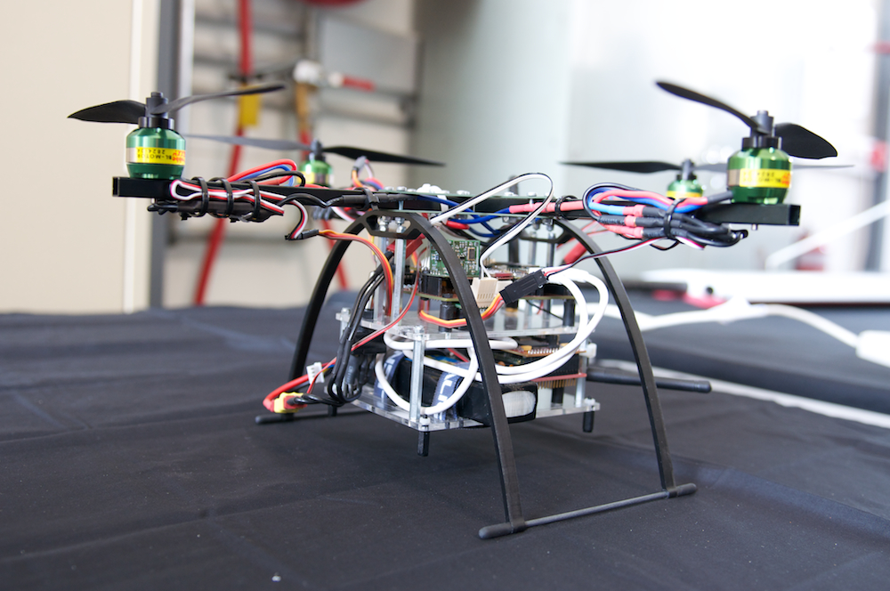

Figure 11 – Platform with Initial Electronics Mounting System

It can be seen in Figure 11 that with the payload attached the bottom tier is very close to the ground, which caused problems in flight-testing when the helicopter was dropped more that thirty centimetres off the ground. Also with the weight of the battery and camera so low with respect to the CoM of the platform, the helicopter was sluggish and hard to control. Also after the camera was no longer required on the platform, it because to difficult to shit the CoM into the desired position. It therefore was required to re-design the mounting system to take account for these developments.

### Final Design Implementation

The final design removed the bottom tier, and moved the battery to the top frame, which in turn moved the CoM to a more appropriate position. Figure 12 shows the final mounting design attached to the landing gear with spacers. The main electronics board is mounted with vibration dampeners, with enough clearance from the airframe above. Also the figure illustrates the mounting system from the communications antenna, which is clipped into the pre-cut hole.

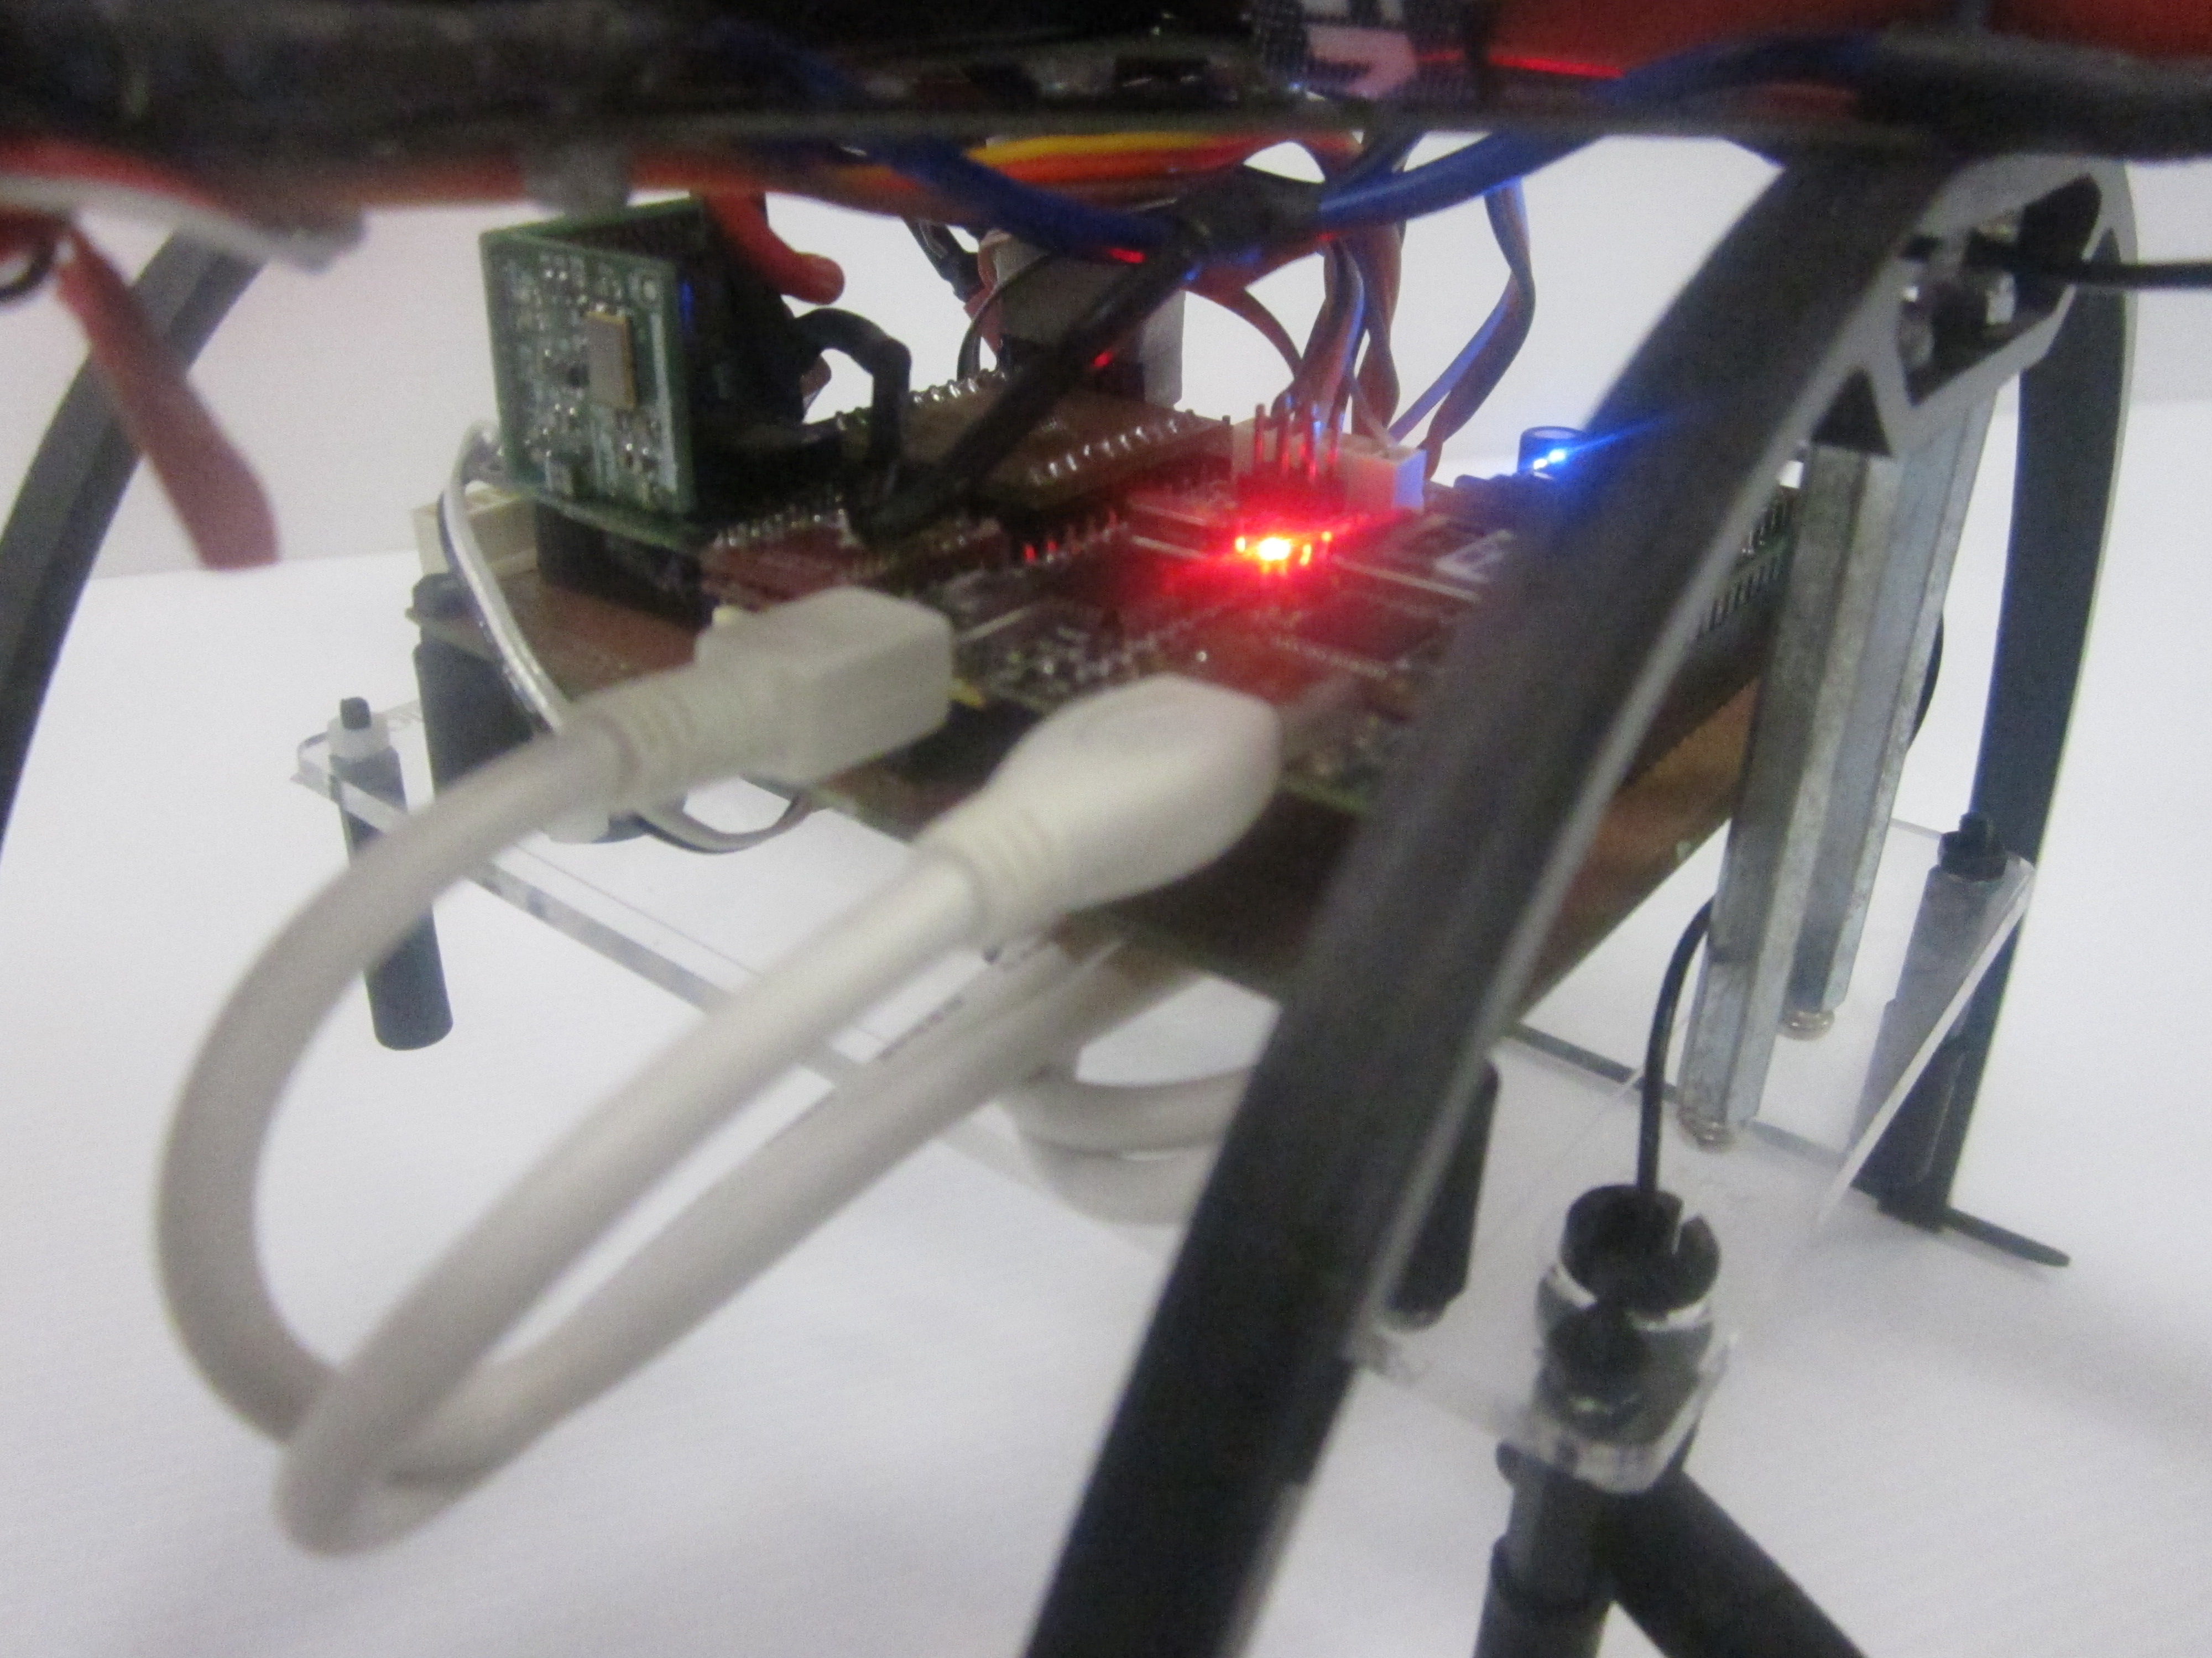

Figure 12 – Final Design of Mounting System

The battery is mounted on top of the airframe, with enough clearance from the spinning propellers. The battery was connected with both Velcro straps, and Velcro dots underneath the battery. Figure 13 outlines the full configuration of the final mounting system design.

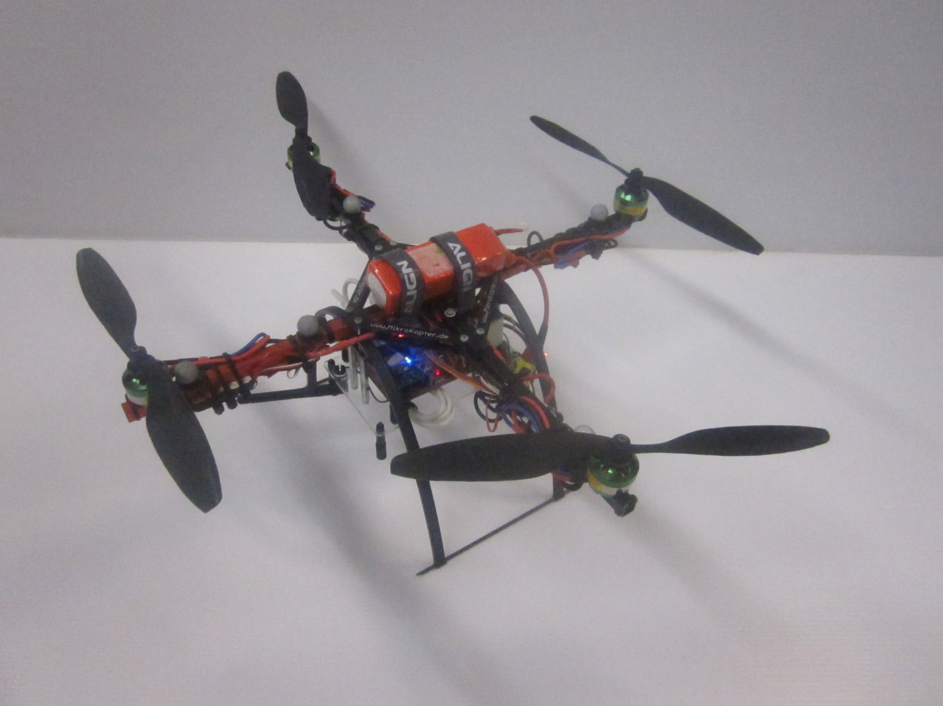

Figure 13 – Battery Mounting for Final Design

# Testing Apparatus Design

## Design

The 2010 Autonomous Helicopter Navigation System will be tested using several stages of restrictions to ensure the safety of team members and damage to the platform is mitigated. Two testing apparatuses were built to restrict the platform during this testing. The following section outlines the design choices throughout the semester, and outlines all designs implemented.

### Objectives of Design

There were no high-level objectives or system requirements regarding the testing platforms, but several design goals were established prior to commencement of design. The following list outlines the informal requirements for both test apparatuses.

* The designs will secure the platform to ensure that it does not move from desired location, even with maximum thrust applied.
* The design will reduce outside effects that would not be present in unrestricted flight-testing.
* The testing apparatuses will not require modifications to the platforms design, and will not need a large length of time to add or remove.

These informal requirements will be factored into all design choices of the testing apparatuses.

## Design Outline

To satisfy the design objectives outlined in section 3.1, it was decided that two apparatuses were to be designed for restricting the AHNS platform during testing. This section will outline the design choices for each testing platform.

### Axis Restricted Apparatus

The axis restricted testing apparatus was designed to only allow the platforms attitude to rotate around one axis, while restricting the helicopters position. The main concept utilises a large frame, which supports the helicopter through two beams that connect into the main spars of the platform. The addition of ball bearing rotation connectors to interface the frame and beams will reduce friction from rotation to allow natural movement. Figure 7 illustrates the axis-restricted system, with the helicopter attached to the main frame by the two beams. The ball bearing connectors are installed behind the square metal connection interface (shown in Figure 15 b)

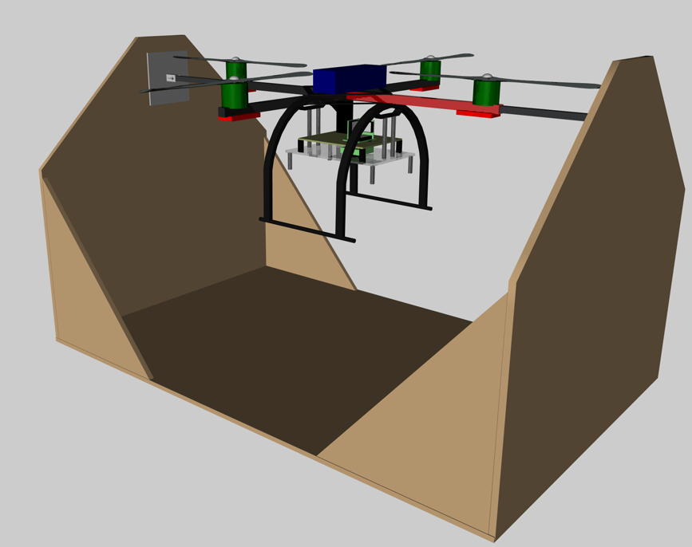

Figure 14 – Illustration of Axis Restricted Testing Rig (Cinema 4D)

Figure 15 illustrates the connection method between the helicopter and the main frame. The metal beam will slide into the square bar of the helicopter with a tight fit, thus allowing quick instillation. The beam will then attach to a manufactured metal plate with tightener to lock the helicopter into place.

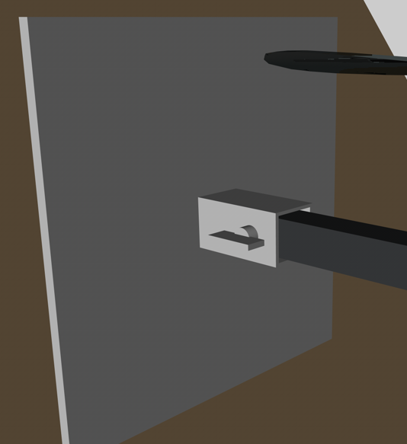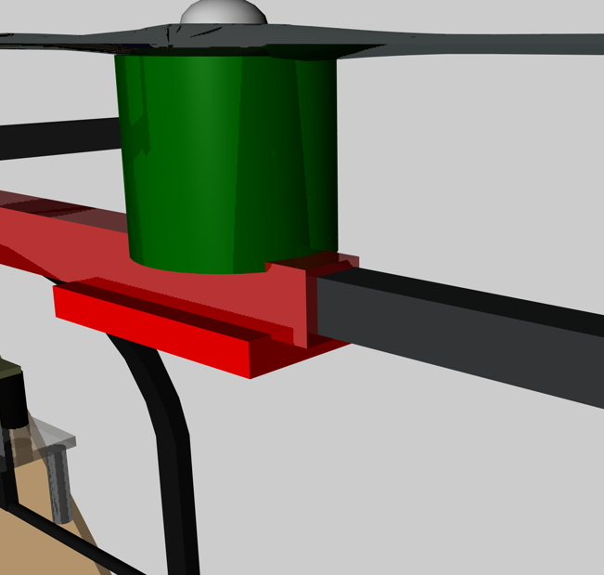

Figure 15 – Beam Attaching to Helicopter / Beam Attaching to Frame (Cinema 4D)

### Bungee Cord Apparatus

The bungee cord apparatus was designed to allow the helicopter to have full attitude control, but restrict the position to a limited area. This system also allows for the helicopters power to be cut at any time with no fear of damaging the platform. The system contains a length of bungee cord connected to a supporting beam on a roof that suspends the helicopter. A rod that protrudes from the centre of the helicopter to above the platform is used to connect the bungee cord and helicopter. Carabineers are also used to allow quick separation from the testing platform.

## Implementation

### Axis Restricted Apparatus

The main frame was constructed with 12 mm thick Medium-Density Fibreboard (MDF), with the use of wood glue and screws to attach the cut pieces together. The metal rods used to suspend the helicopter were manufactured to the correct size to ensure a tight fit into the square bar of the platform. Welded plates were made to attach the metal rods to the main frame, with the ball bearing connected behind using rivets. The ball bearing rotation joints chosen were Lazy Susan, due to their ease in mounting and low costs. Due to the engine shaft protruding into the square beam of the helicopter, the two engines on the axis being rotated had to be removed. This has no effect to the test, as the engines were not contributing to the rotation.

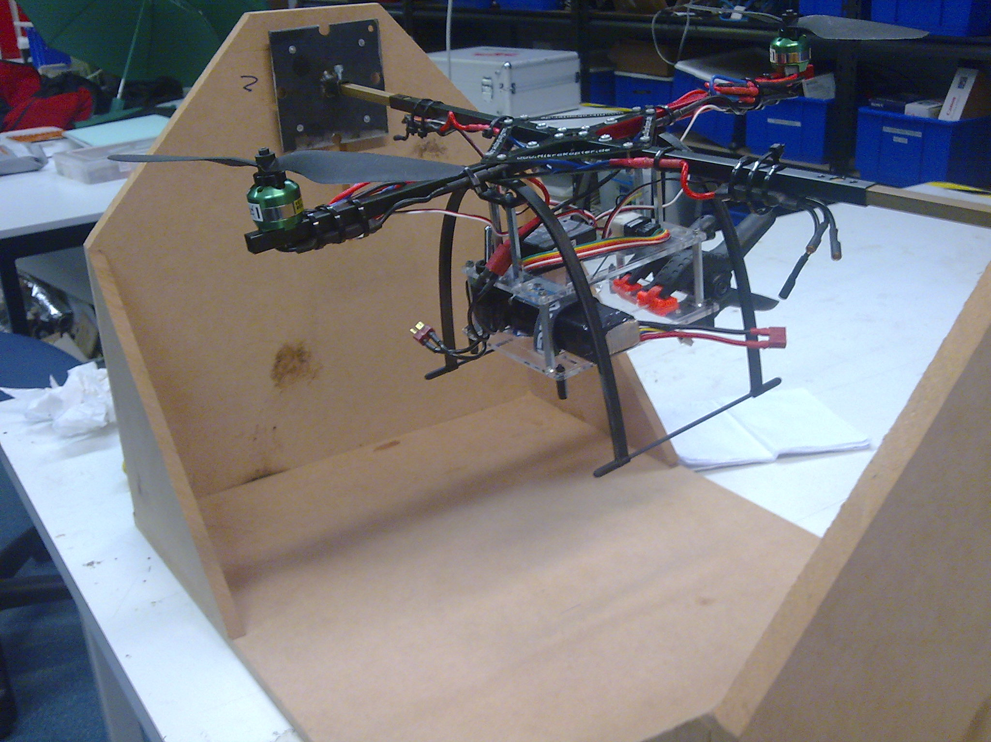

Figure 16 – Axis Restricted Testing Platform

### Bungee Cord Apparatus

The bungee cord used was selected by observing how much a meter long stretched under a 2 kg load. Non-climbing carabineers were used to connect the elastic rope to the platform, with a large swivel to ensure the rope would not splinter under yawing conditions. Figure 17 illustrates the connection rod used to connect the bungee rope to the platform, and that ensures the rope does not come into contact with the spinning helicopter blades. This rod is secured using large washers and four locking nuts. The system is designed for the helicopter to lift to the point were the elastic rope does not support its weight before testing commences.

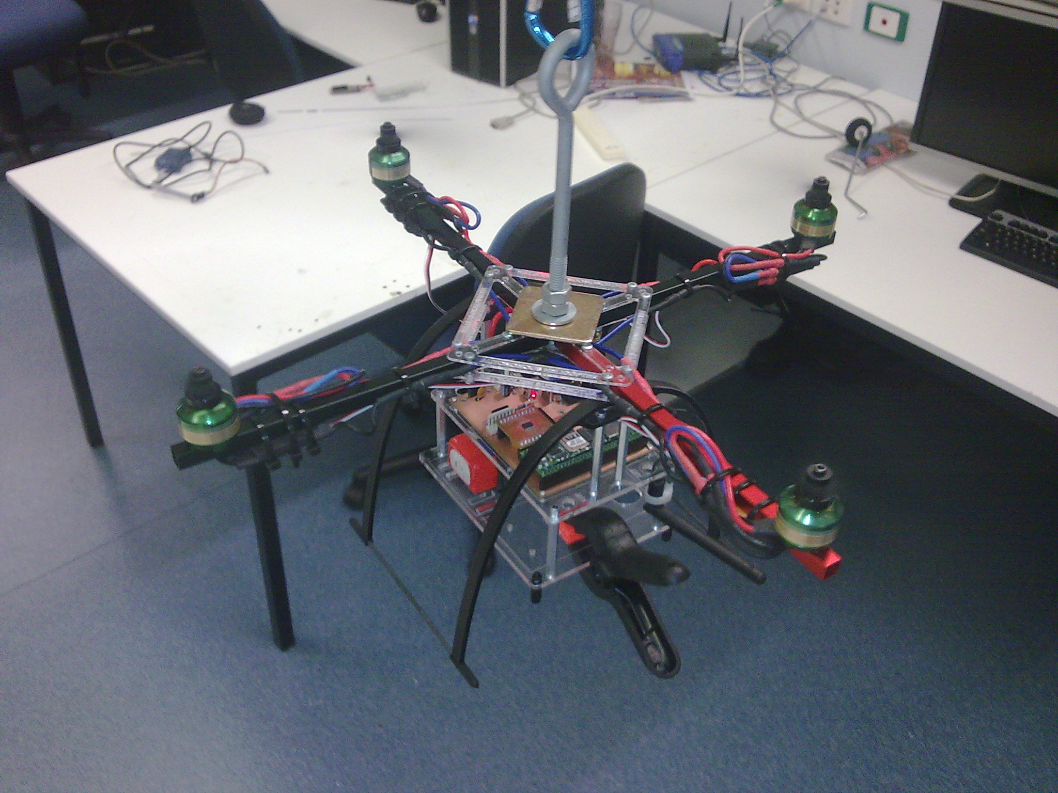

Figure 17 – Bungee Rope Testing Platform

# Requirements Traceability and Conformance

A traceability matrix is necessary to document whether or not the system requirements were verified; and in turn, indicate the standing of the HLOs. The following sections outline the conformance for all system requirements.

## Baseline Requirements

Table 18 - Traceability Matrix for Baseline Requirements

|  |  |  |  |  |
| --- | --- | --- | --- | --- |
| **Number** | **Definition** | **Status** | **Reference Document** | **Additional Information** |
| SR-B-01 | The platform shall have the ability to be manually manoeuvred with a radio controller. | Completed | AHNS-2010-PL-TR-002 |  |
| SR-B-02 | The GCS shall enable autopilot flight mode switching between manual, stability augmented flight, and autonomous station keeping. | Completed | AHNS-2010-GC-TR-001 |  |
| SR-B-03 | The airborne system shall provide control updates at an average rate of 50Hz. | Completed | AHNS-2010-AP-TR-001 |  |
| SR-B-04 | The estimator shall provide Euler angle and rate estimation for the system an average rate of 50 Hz. | Completed | AHNS-2010-SE-TR-001 |  |
| SR-B-05 | The estimator shall provide altitude estimation for the system an average rate of 50 Hz. | Completed | AHNS-2010-SE-TR-001 |  |
| SR-B-06 | The estimator shall provide x and y estimation in an Earth fixed co-ordinate system an average rate of 50 Hz. | Completed | AHNS-2010-SE-TR-002 |  |
| SR-B-07 | The system shall use image processing to aid in state estimation of x and y in an Earth fixed co-ordinate system. | Not Complete |  | The introduction of VICON resulted in the image processing to become redundant. |
| SR-B-08 | The autopilot system gain and reference parameters shall be updatable in flight using an 802.11g WLAN uplink from the GCS. | Completed | AHNS-2010-GC-TR-001 |  |
| SR-B-09 | The airborne system shall transmit telemetry data including state data to the GCS using 802.11g WLAN. | Completed | AHNS-2010-AP-TR-002 |  |
| SR-B-10 | The autopilot control methodology shall be based on cascaded PID control loops. | Completed | AHNS-2010-AP-DD-001 |  |

## Derived Requirements

Table 19 - Traceability Matrix for Derived Requirements

|  |  |  |  |  |
| --- | --- | --- | --- | --- |
| **Number** | **Definition** | **Status** | **Reference Document** | **Additional Information** |
| SR-D-01 | The platform shall be capable of maintaining controlled flight with a total payload of 400 grams. | Completed | AHNS-2010-PL-TR-002 |  |
| SR-D-02 | A maintenance document shall be used to log airframe flight time, battery cycles and aircraft repairs. | Completed | AHNS-2010-PL-TR-001 |  |
| SR-D-03 | The autopilot shall provide stability augmented flight. | Completed | AHNS-2010-SY-TR-001  AHNS-2010-SY-TR-002 |  |
| SR-D-04 | The autopilot shall provide autonomous station keeping capability within a 1 meter cubed volume of a desired position. | Not Completed | AHNS-2010-SY-TR-003  AHNS-2010-SY-TR-004 | Hardware and software fully implemented, but safety concerns stopped testing for position hold. |
| SR-D-05 | The airborne system shall receive and process measurement data from the state estimation and localisation sensors; supporting IMU, Camera, and Ultrasonic sensor. | Completed | AHNS-2010-AP-TR-002 |  |
| SR-D-06 | The airborne system shall collect avionics system health monitoring information in the form of radio control link status, flight mode status and battery level. | Completed | AHNS-2010-AP-TR-002 |  |
| SR-D-07 | The airborne system shall transmit all actuator inputs, including radio control inputs, to the GCS. | Completed | AHNS-2010-AP-TR-002 |  |
| SR-D-08 | The GCS shall log all telemetry and uplink data communications. | Completed | AHNS-2010-GC-TR-001 |  |
| SR-D-09 | Aircraft state data and control inputs received shall be displayable on the GCS along with appropriate time references. | Completed | AHNS-2010-GC-TR-001 |  |
| SR-D-10 | The GCS shall provide display of avionics system health monitoring including telemetry, uplink, radio control link and battery level status read-outs. | Completed | AHNS-2010-GC-TR-001 |  |

## High Level Objective Conformance

Using the information outlined in the traceability matrices for the system requirements, the high level objectives are analysed for level of success. The project goals have been split into six HLO’s, with encompasses all requirements that must be achieved to complete the project.

Table 20 - High Level Objective Conformance Matrix

|  |  |  |  |
| --- | --- | --- | --- |
| **High Level Objective** | **Definition** | **Status** | **Additional Information** |
| HLO-1: Platform | A platform should be developed and maintained to facilitate flight and on board hardware integration. | Completed |  |
| HLO-2: Localisation | The system should be capable of determining its position with the aid of image processing within an indoor environment to an appropriate time resolution. | Not Completed | Due to the introduction of VICON, image processing no longer required. |
| HLO-3: State Estimation | A method of estimating the states of the helicopter system should be designed and implemented. The resolution of the estimations should facilitate their employment in the control system design. | Completed |  |
| HLO-4: Autonomous Hovering Flight | An autopilot system should be developed to enable sustained indoor autonomous hovering flight. The control system should be designed to enable future ingress and egress manoeuvre to longitudinal and hovering flight. | Part Completed | Attitude stability without position hold accomplished. |
| HLO-5: Ground Control Station | A ground control station that supports appropriate command and system setting inputs and data display and logging should be developed. The design should be derived from previous AHNS developments and enable future ground station developments. | Completed |  |
| HLO-6: Communications | The communications system should enable transfer of control, state and localisation data to the ground control station. It should provide with a flexible wireless data link available on consumer-electronic devices. | Completed |  |

## Conformance Diagram

The conformance diagram illustrates the level of success of the entire project utilising colour to show the completion of high level objectives and system requirements. All SR’s are grouped under the ‘parent’ HLO, thus proving if the HLO is complete. The colours used denote the level of success, with Table 21 explaining each meaning.

Table 21 - Verification Colour Meaning

|  |  |
| --- | --- |
| Status | Explanation |
| ACHIEVED | This function requirement was met. |
| NOT TESTED | This functional requirement was part completed, with not all initial objectives complete. |
| NOT ACHIEVED | This functional requirement was not met. |

As shown HLO-1, HLO-3, HLO-5, and all relevant system requirements were completed. HLO-2 failed due to the system requirement SR-B-07 failing, and HLO-4 was part complete, with system requirement SR-D-04 failing.

Figure 18 – Conformance Diagram

# Conclusions

The Autonomous Helicopter Navigation System aim is to develop a helicopter system capable of autonomous control, navigation and localising within a GPS denied environment. The 2010 AHNS project was focused around developing a platform that was capable to stabilise attitude using an on-board PID controller, and design the platform to enable future development.

The system requirements developed at the beginning of the year were all completed, with the exception of one baseline and one derived requirement. The baseline requirement was focused on developing localisation using computer vision, which due to the introduction of VICON, image processing no longer required. The derived requirement that was not completed was to achieve position hold to a desired location. The hardware and software for this requirement were designed and implemented into the platform, but due to safety concerns with testing the position hold, the requirement was never tested.

The main accomplishments of the 2010 AHNS project were the designed and constructed a platform to facilitate flight utilising on board hardware and sensors, implemented State Estimation and PID control to enable autonomous flight, a coded functional ground control station with 2.4 GHz wireless communication to platform, tuned platform gains that achieve stable platform attitude while in flight, and enabled future development on project to achieve position hold.

The 2010 Autonomous Helicopter Navigation System project accomplished most of its system requirements, and produced a platform and software package that will enable future teams to progress to a fully functional indoor autonomous helicopter system

## Lessons Learnt

At the completion of the project, after time to reflect on the progress of the project, recommendations were recorded below. Their purpose are to be used for future years to ensure difficulties and poor decisions faced this year are not repeated.

### System Level

The following recommendations for the system level and administration of the AHNS project should be taken into consideration for future projects.

* Ensure all system requirements and preliminary designs are defined early, as changes to the goals or system introduces large scheduling risks.
* The work breakdown structure should be organised into large overall tasks, as the project aims, designs and methods will change during the semester, therefore resulting in project plans that do not lead to the desired outcome.
* The testing phase of the project should commence at the beginning of semester two, as the AHNS project requires a lot of time for calibrating the system for flight conditions.
* Organise the project time schedule to incorporate other subject assignment due dates, as project productivity was found to drop significantly during this time.
* The risk management plan must be completed and approved well before testing commences, and ensure that all possible testing locations has been authorised.
* Safety with the platform while being powered is paramount, as engines can often start without warning with unverified code.
* Ensure all flight tests are recorded for future review against logged data.
* Due to batteries requiring four times longer recharging that the flight time they produce, ensure a large number are available for flight-testing.
* Purchase additional electrical hardware components to mitigate schedule delay from broken parts after flight crashes.

### Hardware Mounting System

The following recommendations should be implemented into future hardware mounting system designs.

* Manufacture a lot of enclosures for flight-testing, as running out during a flight sessions results in loss in testing time.
* Ensure the centre of mass of the platform is as close to the original airframe as possible, as altering it dramatically changes the flying quality.
* Design the distance between the underside of the mounting system to the ground as large as possible, as it reduces the chance of impact from platform fall by letting the landing gear take the force.

### Testing Apparatus

The recommendations outlined below should be considered for future designs in testing apparatuses.

* Although testing apparatuses reduce the risk of personal injury or property damage, they introduce far to many other factors. This in turn completely changes the dynamics of the system, and any data collected using them could be considered useless.
* The testing apparatus is ideal for initial tests; such as engine thrust testing, weight load testing, and input direction identification.
* All gain tuning should only be attempted with the system unrestricted. By applying enough thrust to lift the platform off the ground, and then observe its behaviour, the gains can be tuned. This method is low on risks, and does not introduce outside influences on the system.

Associated Websites

[A1] AHNS Source code repository: <http://ahns10.googlecode.com/svn/>

List of Appendices

1. Work Packages
   1. AHNS-2010-SY-PM-001 Project Management Plan Work Packages
2. Risk Management Plan Risks
   1. AHNS-2010-SY-PM-002 Risk Management Plan Risks